# Implementing PSO using Lookup Table:-

Pmpp = 180 W

Voc=43.64

Isc=5.45

Vmp=36.36

Imp=4.95

Dmpp = 0.88 (calculated from Lookup Table and assuming Rload)

Step 1: lookup Table is generated

for V = 0.01 to V = 43.6,

I is calculated using IV curve.

Hence, Effective R is calculated for every point.

Step 2: Considering Boost Convertor,

Reff = Rload * (1-d)2

Rload is chosen as 500 Ω.

Step 3: Power vs duty curve is also plotted using above formula (taking Rload =500 Ω).

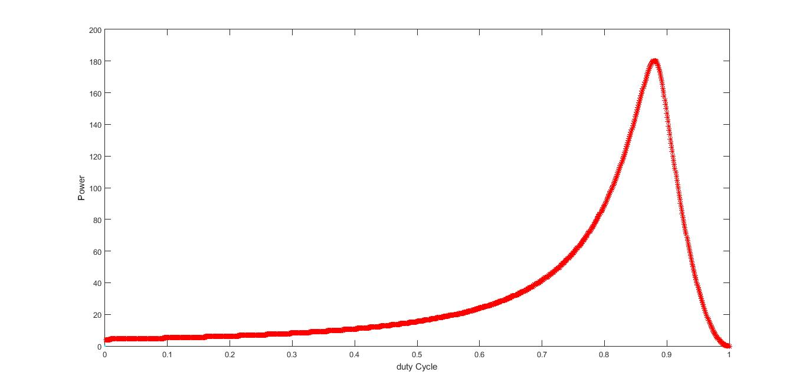

For PSO ::

Pk+1 = Pk + Vk

VK+1 = w*Vk + c1*r*(Pl - Pk) + c2*r*(Pg - Pk)

***Simulation 1 ::***

Variables => w=0.1

C1 = 0.2

C2 = 0.2

R = 0.4

Particles => D1 = 0.40 (both side of dmax)

D2 = 0.60

D3 = 0.95

Result :: Particles converges (within 2% of Pmpp) after 43rd Iteration.

***Simulation 2::***

Variables => w=0.1

C1 = 0.2

C2 = 0.2

R = 0.4

Particles => D1 = 0.40 (Same side of dmax)

D2 = 0.60

D3 = 0.80

Result :: failed to converge even after 50 iterations (Pmax reached = 88W)

***Simulation 3::***

Variables => w=0.5 (improved Parameter values)

C1 = 0.5

C2 = 0.5

R = 0.5

Particles => D1 = 0.40 (Same side of dmax)

D2 = 0.60

D3 = 0.80

Result :: Fast convergence. Find MPP in 14 iterations. Good results.

***Simulation 4::***

Variables => w=0.5

C1 = 0.5

C2 = 0.5

R = 5 (made x10 from the last simulation)

Particles => D1 = 0.40 (Same side of dmax)

D2 = 0.60

D3 = 0.80

Result :: failed to converge even after 50 iterations (high velocity, unstable movement)

***Simulation 5::***

Variables => w=0.9 (High Value of W)

C1 = 0.5

C2 = 0.5

R = 5

Particles => D1 = 0.40 (Same side of dmax)

D2 = 0.60

D3 = 0.80

Result :: Particles got MPP in 11 iterations but keep oscillating around Mpp with big variations

***Simulation 6::***

Variables => w=0.9 (High Value)

C1 = 0.5

C2 = 0.5

R = 1 (Moderate Value)

Particles => D1 = 0.40 (Same side of dmax)

D2 = 0.60

D3 = 0.80

Result :: got MPP in 2 iterations. But failed to converge, oscillations are large (May be useful with Shifting MPP).

***Simulation 7::***

Variables => w=0.5

C1 = 0.5

C2 = 0.5

R = 1 (moderate value)

Particles => D1 = 0.40 (both side of dmax)

D2 = 0.60

D3 = 0.95

Result :: converges in 10 iterations. Initially they oscillated about MPP, after 4-5 iterations all became static

***Simulation 8::***

* ***Test 1***

Variables => w=0.5

C1 = 0.5

C2 = 0.5

R = 1

Particles => D1 = 0.81 (chosen Randomly)

D2 = 0.90

D3 = 0.12

Result :: got MPP in 2 Iterations and all converges in 13 iterations

* ***Test 2***

Variables => w=0.5

C1 = 0.5

C2 = 0.5

R = 1

Particles => D1 = 0.91 (chosen Randomly)

D2 = 0.632

D3 = 0.097

Result :: got MPP in 9 iterations and converges in next 3-4 iterations

* ***Test 3,4,5… 90-95% chances of convergence at MPP (failed to converge only when particles were closely initialize and were away from MPP)***

***Simulation 9::***

* ***Test 1,2,3… 90-95% chances of convergence at MPP (failed to converge only when particles were closely initialize and were away from MPP)***